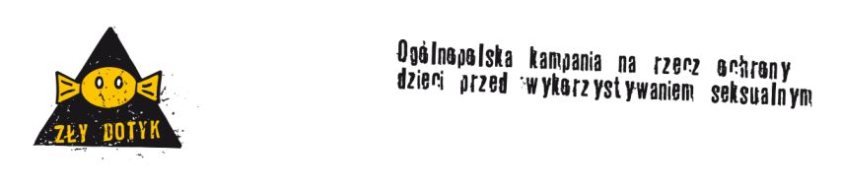

Position statement of Nobody’s Children Foundation for “Bad Touch” campaign

Recognizing that:
- every child has the right to be protected by its family, by the society and by the state from sexual abuse and all forms of sexual exploitation,

- experiencing sexual abuse is detrimental to the child’s health and psychosocial development,

- preventing and combating child sexual abuse and sexual exploitation – given the disturbing scale of the problem – calls for interdisciplinary cooperation and international involvement,

we hereby urge the Parliament of the Republic of Poland to swiftly ratify the Council of Europe Convention on the Protection of Children against Sexual Exploitation and Sexual Abuse, adopted by the Committee of Ministers on 12 July 2007,
and signed by the Republic of Poland on 25 October 2007.

In order to ensure that all stipulations of the Convention are implemented in the Polish legal system, we propose that adequate actions should be taken and legislative changes instituted, aimed at:

1. Introducing legal obligation for all individuals who in their professional capacity have regular contact with children to present a certificate of non-conviction regarding sexual crimes against children.

2. Providing all individuals who in their professional capacity have regular contact with children with adequate knowledge regarding child sexual abuse, identification of abuse cases and opportunities for intervention.

3. In the course of education, providing children with information – properly adjusted to the child’s comprehension skills at a given stage of development - regarding potential threats associated with sexual abuse, as well as possible measures of protection against such threats.

4. Offering emergency assistance and long-term help to victims of sexual abuse, enabling them to recover physically and psychosocially. Ensuring necessary support for victims’ families and caregivers.
